**Livermore Fire Protection Board Income Statement**

**2024**

|  |  |  |  |  |  |  |  |  |  |  |  |  |  |  |  |
| --- | --- | --- | --- | --- | --- | --- | --- | --- | --- | --- | --- | --- | --- | --- | --- |
| **Income**  **OPERATING INCOME** | **2024 Adopted Budget** | **1/24** | **2/24** | **3/24** | **4/24** | **Actual Monthly Income**  **5/24 6/24 7/24** | | | **8/24** | **9/24** | **10/24** | **11/24** | **12/24** | **Total Income Jan 24 - Dec 24** | **Under/Over Budget** |
| **Donations**  **Fundraising**  **Stripe**  **Kroger**  **Grants EMS Grant**  **Impact Assistance Grant**  **Interest Income**  **Miscellaneous Income**  **Insurance Payout**  **Air Med Commissions**  **Property Taxes**  **Sale of Equipment Specific Ownership Tax**  **Total Income** | **$8,000.00**  **$6,000.00** | **$1,050.65** | **$4,250.00** | **$300.00** |  | **$1,500.00** |  |  |  | **$2,300.00** |  |  |  | **$9,400.65 $0.00** | **$1,400.65**  **($6,000.00)** |
| **$0.00**  **$0.00** | **$432.15** | **$245.06** |  |  | **$274.13** |  |  | **$280.82** |  |  |  |  | **$432.15**  **$800.01** | **$432.15**  **$800.01** |
| **$0.00**  **$0.00** |  |  |  |  |  |  | **$20,169.62** |  |  |  |  |  | **$0.00**  **$20,169.62** | **$0.00**  **$20,169.62** |
| **$0.00 $4,000.00** | **$343.99** | **$298.72** | **$397.16** | **$467.24** | **$493.08** | **$688.12** | **$766.51** | **$1,812.30 $829.25** | **$901.37** |  |  |  | **$1,812.30**  **$5,185.44** | **$1,812.30**  **$1,185.44** |
| **$0.00**  **$0.00** |  |  |  |  | **$1,400.00 $372.32** |  |  |  |  |  |  |  | **$1,400.00 $372.32** | **$1,400.00 $372.32** |
| **$0.00**  **$316,000.00** |  | **$70.68**  **$2,222.03** | **$141.36**  **$127,093.02** | **$87,455.23** | **$89,936.22** | **$31,541.62** | **$92.28**  **$87,120.29** | **$3,784.68** | **$4,431.60** |  |  |  | **$304.32**  **$433,584.69** | **$304.32**  **$117,584.69** |
| **$1,000.00**  **$20,000.00** | **$1,427.84** | **$2,117.25** | **$1,957.92** | **$2,142.34** | **$1,980.12** | **$2,000.04** | **$1,871.62** | **$2,177.07** | **$2,242.00** |  |  |  | **$0.00**  **$17,916.20** | **($1,000.00)**  **($2,083.80)** |
| **$ 355,000.00** | **$3,254.63** | **$9,203.74** | **$129,889.46** | **$90,064.81** | **$95,955.87** | **$34,229.78** | **$110,020.32** | **$8,884.12** | **$9,874.97** | **$0.00** | **$0.00** | **$0.00** | **$491,377.70** | **$136,377.70** |

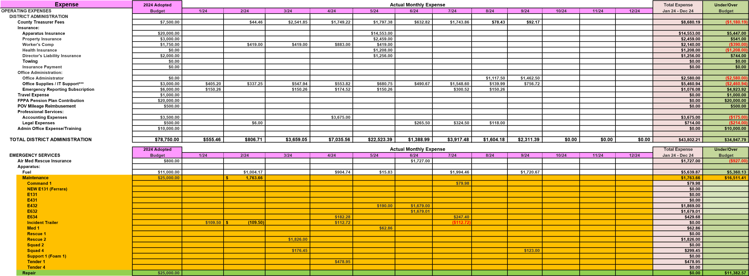

**Page 1 of 2**

**Livermore Fire Protection Board**

**Income Statement**

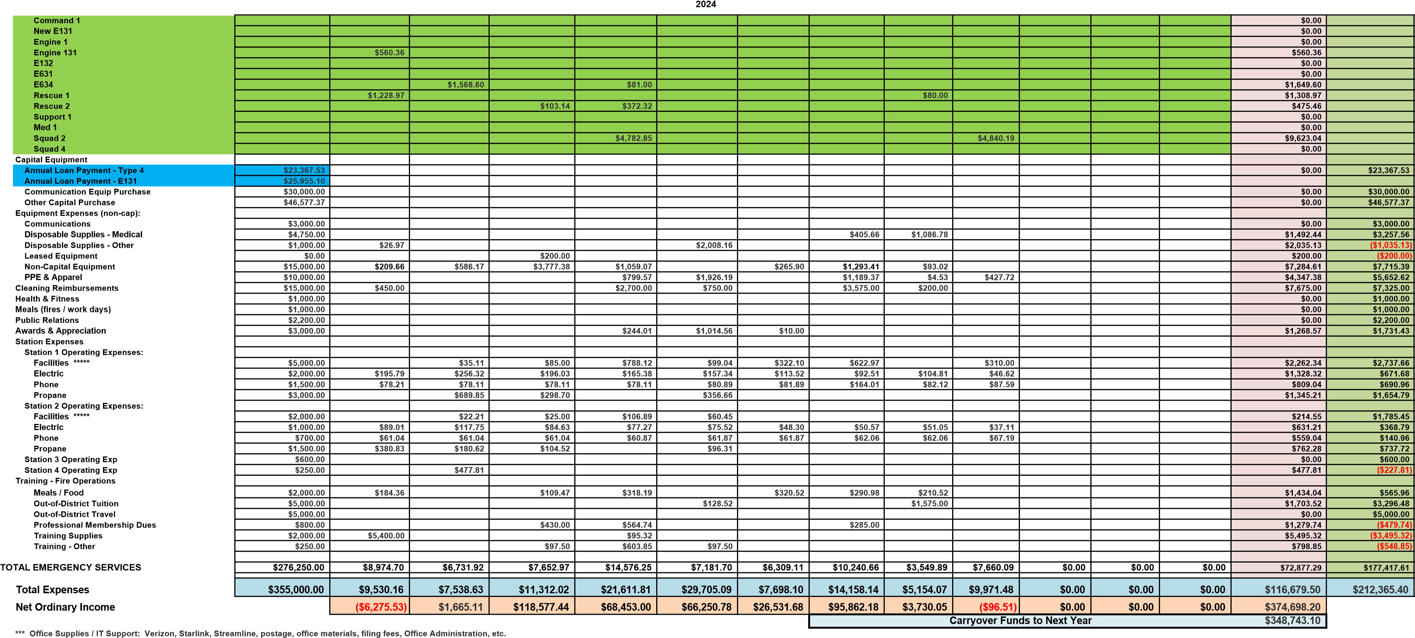

**\*\*\*\*\* Facilities expenses includes maintenance contracts on generators, snow removal, repairs, etc**

**Payments on Appartus will not show up on the Income Statement because they are paid from a liability account - both were paid Q1 of 2024.**

**Budget changes**

**Page 2 of 2**